04-03-2010
George K. Aidoo
SM/SMS/09/0019
Physics Practical

Experiment 3

Vibration of Strings

AIM: This experiment aims to determine and measure the density of a material in the form of a string (e.g. constantan).

APPARATUS:

String tensioning device (1), nickel wire (1), meter scale, demo, l = 1000mm (1), spring balance (1), striking rubber hammer (1), photoelement f. opt. base plt. (1), lamp holder E10, housing G1 (1), lamp bulb 6 V/3 W, E10 (1), distributor (1), oscilloscope, 30 MHz, 2 channels (1), LF amplifier, 220 V (1), digital counter, 4 decades (1), plug with push-on sleeve (1), adapter, BNC socket – 4mm (2), adapter, BNC-plug/socket 4mm (1), connector, T type, BNC (1), screened cable, BNC, l = 750mm, screened cable, BNC, l = 300mm, connecting cord, l = 750mm (red and blue, 1 each).

DIAGRAM/SETUP:

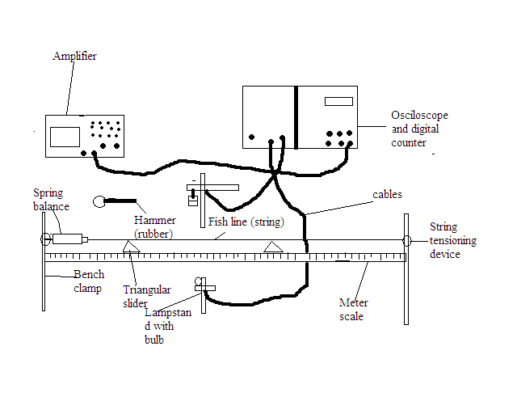

THEORY:

The fundamental frequency of a string of length l tensioned at both ends is given by: f = 1/2L x (√T/µ), where T = tension and µ = mass per unit length. This theory basically states that the frequency at which a string vibrates is directly equivalent to one over twice the length of the string multiplied by the squared root of the tension in the string over the squared root of the mass per unit length of the string.

PROCEDURE:

The string was laid across two triangular sliders clamped between a fixed hook and a spring balance, as shown above. The string balance was attached to a string tensioned with fishing line. The tensioned force was exactly 10 N. The string length was set by moving the triangular sliders along the measuring scale. The vibration of the string was then optically scanned midway between the sliders. The signal from the photo-cell, fitted with an aperture slit, was amplified and transmitted to the oscilloscope and the counter/timer. The string vibration was to be started with a gentle tap of the rubber hammer, and the counter/timer was to be started once the harmonics had died away. The tension and diameter of the nickel string used were measured and recorded. With the tension constant at 10 N, a string length of 40cm was measured between the two triangular sliders, the counter/timer device was set to record frequency (KHz), the sensor was aligned to the string using light so that the counter read zero, the start button was pushed and then the string was struck gently at the middle, between the two triangular sliders, to start the vibrations. Once the frequency became stable; the harmonics died away, the stop button was pushed and the frequency was recorded. The process was repeated for four other values of the l = 50, 60, 70, and 80 cm. The frequency at these lengths was recorded.

TABLE OF RESULTS (observations):

F / KHz | L / cm
0.130 | 40
0.105 | 50
0.080 | 60
0.075 | 70
0.067 | 80

Table of Frequency and 1/L:

1 / L | F / KHz
0.025 | 0.130
0.020 | 0.105
0.016 | 0.080
0.014 | 0.075
0.012 | 0.067

Graph of frequency against 1/L:

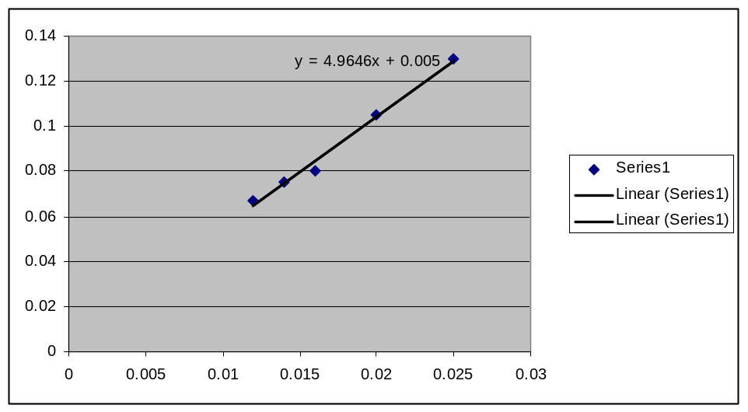

Calculation of µ (mass per unit length) and density of string:

Using the equation: f = 1/2L(√T/ µ), which can be simplified as:
[f (2L)]² = (√T/ µ) ²
[f (2L)]² = (T/µ)
µ[ f(2L)]² = T
µ = T/[f(2L)]², the mass per unit length of each string of different length can be determined as follows:

For string of length 40cm,
µ = 10/[0.130(2x40)]²
µ = 0.0925

For string of length 50cm,
µ = 10/[0.105(2x50)]²
µ = 0.0907

For string of length 60cm,
µ = 10/[0.080(2x60)]²
µ = 0.109

For string of length 70cm,
µ = 10/[0.075(2x70)]²
µ = 0.091

For string of length 80cm,
µ = 10/[0.067(2x80)]²
µ = 0.087

DISCUSSION:

According to the results obtained from the experiment; looking at the first table, with constant tension of 10N in a string, the frequency of vibration decreases as the length of the string increases. That is an inverse proportionality relation. Although the same string was used in this experiment, the change in length of the string had a direct influence on the mass per unit length of the string, as is shown in the calculations above. It can also be observed that the frequency of vibration in the string was directly dependent on the tension in the string and inversely dependent on the mass per unit length of the string. The graph shows a correlation between the frequency of vibration and one by each of the lengths of the string used in the experiment. It clearly shows an inverse relationship between frequency and the length of the string, as the slope of the graph shows. In view of these observations, it can be concluded from the simplified equation of the theory above that theory is correct.

SORCES OF ERROR:

- Errors may have occurred from the measuring instrument, which was moved when the length of the string was being set. This may have caused inaccuracy in length determinations.
- The digital oscilloscope may have given inaccurate readings of the exact frequency of vibration because of inaccuracy in placing the string directly in front of its scanner.

PRECAUTIONS:

- Values for the frequency were taken several times each to ensure accuracy.
- The string was struck at the same point each time to ensure accuracy and uniformity in each of the values of frequency taken.

CONCLUSION:

The aim of the experiment to determine the density; the mass per unit length of the string was achieved, and the theory was proved to be accurate.

REFERENCES:

SERWAY, Raymond A.,
College Physics/Raymond A. Serway, Jerry S. Faughn, - 6th edition, Pacific Groove, CA 93950. USA. Pg. 412-413

